# Module 3 - Assignment 3

## Pierce, Michaela

### More Practice with Plots

# Load the tidyverse package  
library(tidyverse)

## ── Attaching core tidyverse packages ──────────────────────── tidyverse 2.0.0 ──  
## ✔ dplyr 1.1.4 ✔ readr 2.1.5  
## ✔ forcats 1.0.0 ✔ stringr 1.5.1  
## ✔ ggplot2 3.5.0 ✔ tibble 3.2.1  
## ✔ lubridate 1.9.3 ✔ tidyr 1.3.1  
## ✔ purrr 1.0.2   
## ── Conflicts ────────────────────────────────────────── tidyverse_conflicts() ──  
## ✖ dplyr::filter() masks stats::filter()  
## ✖ dplyr::lag() masks stats::lag()  
## ℹ Use the conflicted package (<http://conflicted.r-lib.org/>) to force all conflicts to become errors

library(readr)  
GOOG <- read_csv("GOOG.csv", col_types = cols(Date = col_date(format = "%Y-%m-%d")))  
#view(GOOG)

#### Google Stock Price Plots

The following is an analysis of Google’s stock price from October of 2019 to October of 2020. This will include a scatter, line, bar, histogram and boxplot. All the plots represent the closing price on the dates listed on the x-axis.

# Scatterplot  
ggplot(GOOG, aes(x = Date, y = Close)) +  
 geom_point() +  
 labs(title = "Scatterplot of Close Price over Time",  
 x = "Date",  
 y = "Close Price")

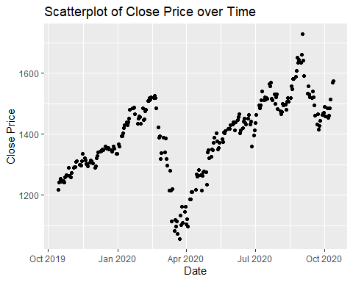

# Line Graph  
ggplot(GOOG, aes(x = Date, y = Close)) +  
 geom_line() +  
 labs(title = "Line Graph of Close Price over Time",  
 x = "Date",  
 y = "Close Price")

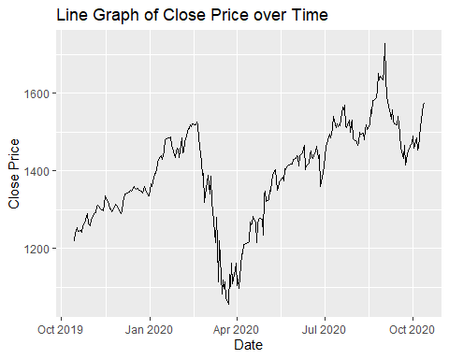

# Bar Graph  
ggplot(GOOG, aes(x = Date, y = Close)) +  
 geom_col() +  
 labs(title = "Bar Graph of Close Price over Time",  
 x = "Date",  
 y = "Close Price")

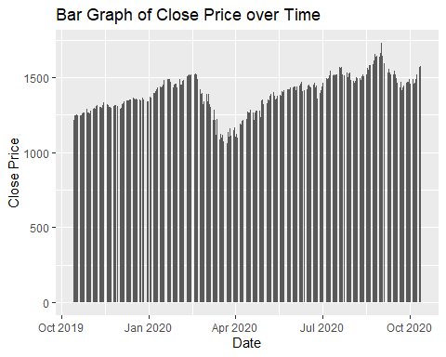

# Histogram  
ggplot(GOOG, aes(x = Close)) +  
 geom_histogram(binwidth = 10, fill = "lightblue", color = "black") +  
 labs(title = "Histogram of Close Prices",  
 x = "Close Price",  
 y = "Frequency")

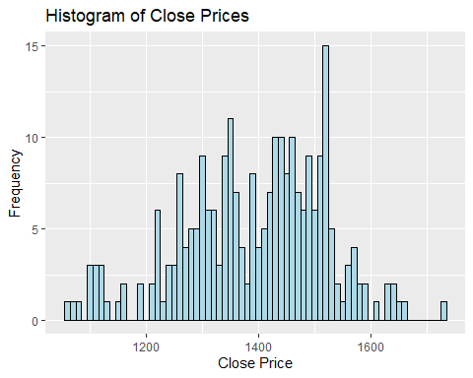

# Box Plot  
ggplot(GOOG, aes(x = Close)) +  
 geom_boxplot() +  
 labs(title = "Box Plot of Close Prices",  
 x = "Close Price",  
 y = "Frequency")

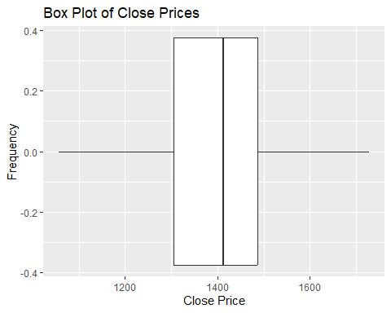

# Line Graph with points  
ggplot(GOOG, aes(x = Date, y = Close)) +  
 geom_line() +  
 geom_point() +  
 labs(title = "Line Graph with Points of Close Price over Time",  
 x = "Date",  
 y = "Close Price")

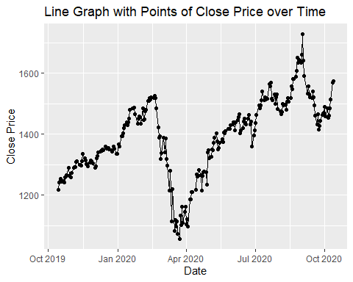

#You have created many different plots of the same data but some are more helpful than others.   
#Based on the plots you created, which one do you find most useful and why?

I find the line graph with points to be the most useful.It makes the data easier to read visually. I like that it is like a scatterplot and linechart. It is easier to see the trends and see spikes or drops in the data.

#### Google Stock Daily Price Comparisons

ggplot(GOOG) +  
 geom_line(aes(x=Date, y=High, color="High"))+  
 geom_line(aes(x=Date, y=Low, color="Low"))

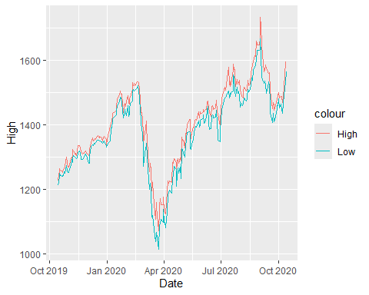

# Line chart with Open and Close variables  
ggplot(GOOG) +  
 geom_line(aes(x = Date, y = Open, color = "Open")) +  
 geom_line(aes(x = Date, y = Close, color = "Close")) +  
 labs(title = "Comparison of Open and Close Prices",  
 x = "Date",  
 y = "Price")

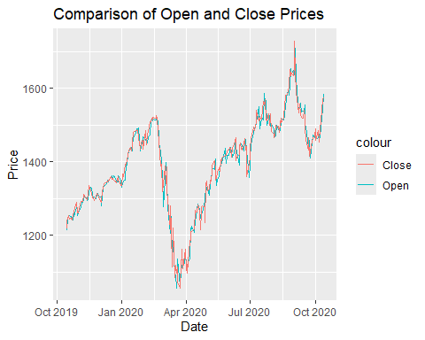

# Google Stock Daily Price Comparisons  
## Area plot comparing High and Low prices  
  
ggplot(GOOG, aes(x=Date, y=Close)) +  
 geom_area(color="black", fill="blue", alpha=.2)

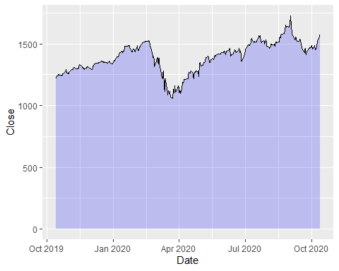

# Plots Date and Open variables  
ggplot(GOOG, aes(x=Date, y=Open)) +  
 geom_area(color="black", fill="green", alpha=.10)

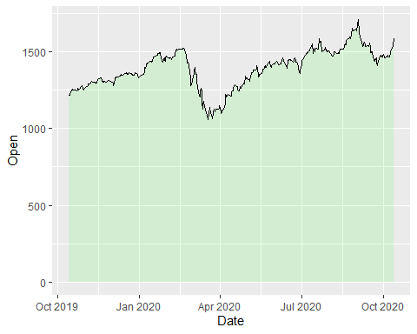

#NewDataFile <- subset(ExistingData, Argument)  
MayPrice <- subset(GOOG, Date > "2020-04-30" & Date < "2020-06-01")  
  
ggplot(MayPrice, aes(x=Date, y=Close)) +  
 geom_point() +  
 geom_text(aes(label = round(Close)), size = 3, vjust=-1)

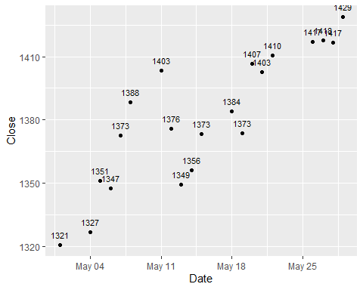

# Create a subset for AprilPrice  
AprilPrice <- subset(GOOG, format(Date, "%Y-%m") == "2020-04")  
  
# Create a scatterplot of Date and Open price for April  
ggplot(AprilPrice, aes(x = Date, y = Open)) +  
 geom_point() +  
 geom_text(aes(label = Open), size = 2, vjust = 1.5) +  
 labs(title = "Scatterplot of Date and Open Price for April",  
 x = "Date",  
 y = "Open Price")

